Aspiration Assisted Motor-Driven Biopsy Needle

Report: 11-7-2024

1. **Work Planned to be Completed:**

There are three focuses for this week: (1) Investigation of a USB accessible Mass Storage Class using the RP2040, (2) Narrowing down of battery selection, and (3) Implementation of RPM calculations with our current circuit.

1. Right now we are using an Arduino R3 to handle the processing and the little data transfer we have via a serial monitor. This is not sustainable if we want any automatic organization of output data. Instead, we can use something like the RP2040 which comes with USB MSC capabilities. I would need to write a lot of code but the general idea is that when the device is plugged into a computer, it would work much like a flash drive. I intend to get started with this, at least getting the basic infrastructure for it.
2. Battery selection is important if we are seriously considering the device’s handheld operation. I am planning to format a document that summarizes all the available options and configurations as well as general considerations.
3. RPM calculations shouldn’t be too difficult to accomplish with our current code. I already have the code necessary to calculate the revolutions that occur after operation. All I would need to do is get some similar variables and implement a timer counter. In addition to this I would like to debounce the pushbutton we have right now or atleast investigate if it will be an issue.
4. *Additionally, if I can, I would like to make more progress on the KiCad library. Given that PCB design is still a ways off, this is lower in priority.*
5. **Work Completed:**

I was not able to explore the RP2040 as much as I would have liked to this week. So far I’ve watched a couple of videos and read a few guides as to how I could make the SD card work as an MSC through USB connection. I am hoping to get some functional code for it by Friday.

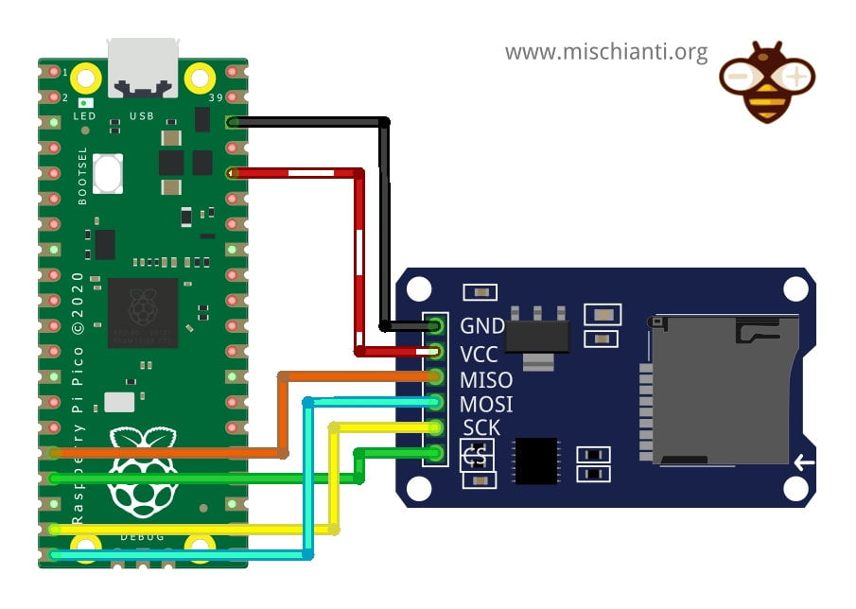

***Figure 1:*** *Potential method for connecting SD card or micro SD to RP2040.*

For battery selection, I wrote a document comparing different types of cells and several different considerations when making a purchase. I have narrowed down on a 3S LiPo or Li-Ion configuration. These cells typically have a nominal voltage of 4.2 with three in series making 12.6 V. Even as it discharges, so long as we regulate charging and have indicators for the battery level, this should be able to supply the motor. Importantly, I am also looking at how the charging will be handled. Generally, LiPo and Li-Ion battery packs require special chargers to balance each cell evenly and prevent overcharging and damage. However, I am looking into how we could have it so the device could be charged through something similar to a iPhone charger which would ideally be more intuitive. This is further detailed in my battery selection document.

***Figure 1:*** *Battery Selection document to be worked on further after determining general operational characteristics.*

RPM calculations have now been implemented in our current circuit. Right now they update once a second. This took significantly more time to do than I expected. My original plan was to have a timer count the duration between rising edges but this would not work so instead I set an 1 second timer and just counted how many pulses occurred. This could be written so that it would be output on the LCD but the question is just where,

***Figure 2:*** *RPM calculation implemented.*

Additionally, I made some general code changes, cleaning up some of the comments and formatting to make it look less cluttered. I also pushed all the button code into a handler which will make it easier to implement software debouncing.

1. **Future Work:**

My main priorities are getting the USB MSC capability with an SD card, selecting and purchasing the battery and moving over all the current code to work with the RP2040 instead of the Arduino. As we approach the prototype I need to also finish the KiCAD library.

**Current CEN3907C Due Dates**

|  |  |
| --- | --- |
| *Assignment* | *Due Date* |
| Pre-Alpha Build | 10/25 |
| Driver Lab | 11/1 |
| Elected Lab | 11/14 |
| Design Plan Revision | 11/1 |
| Prototype Presentation | 11/19 |
| Design Prototype | 11/22 |
| Presentation Reviews | 12/3 |